Task - 17/09/2020

**Task 1 : Show max marks**

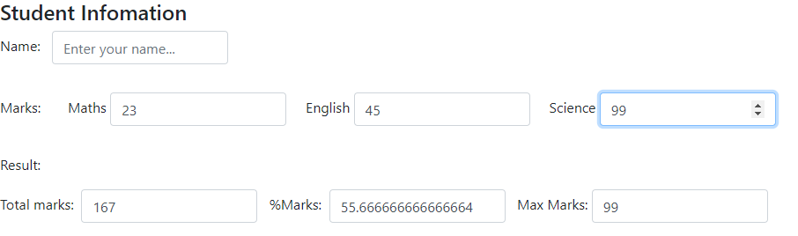

my-component.component.ts  
-----------------------------------------------------------------------------------------------------------------------------------------

import { Component, OnInit } from '@angular/core';

@Component({

  selector: 'app-my-component',

  templateUrl: './my-component.component.html',

  styleUrls: ['./my-component.component.css']

})

export class MyComponentComponent implements OnInit {

  mathsmarks:number;

  englishmarks:number;

  sciencemarks:number;

  constructor() { }

  ngOnInit(): void {

  }

  func():number{

    return Math.max(this.mathsmarks,this.sciencemarks,this.englishmarks);

  }

}

-----------------------------------------------------------------------------------------------------------------------------------------

my-component.component.html  
-----------------------------------------------------------------------------------------------------------------------------------------

<h4>Student Infomation</h4>

    <div class="form-group form-inline">

    <p>Name: &nbsp; <input type="text" class="form-control"  placeholder="Enter your name..."></p>

    </div>

    <div class="form-group form-inline">

        <p>

            Marks:&nbsp;&nbsp;&nbsp;&nbsp;&nbsp;&nbsp;

            Maths&nbsp;<input type="number" class="form-control" [(ngModel)]="mathsmarks" placeholder="Enter maths marks..."/>

            &nbsp;&nbsp;&nbsp;

            English&nbsp;<input type="number" class="form-control" [(ngModel)]="englishmarks" placeholder="Enter english marks..."/>

            &nbsp;&nbsp;&nbsp;

            Science&nbsp;<input type="number" class="form-control" [(ngModel)]="sciencemarks" placeholder="Enter science marks"/>

        </p>

    </div>

    <div>

        <p>Result:</p>

    </div>

    <div class="form-group form-inline">

        <p>Total marks: &nbsp;<input type="number" class="form-control" value="{{mathsmarks+englishmarks+sciencemarks}}">&nbsp;&nbsp;&nbsp;%Marks: &nbsp;<input type="number" class="form-control" value="{{(mathsmarks+englishmarks+sciencemarks)/3}}">&nbsp;&nbsp;&nbsp;Max Marks:&nbsp;<input type="number" class="form-control" value="{{func()}}"></p>

    </div>

-----------------------------------------------------------------------------------------------------------------------------------------

**Task 2 : use ngIf and ngFor , show students of age less than 35**

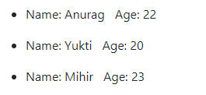

my-component.component.ts  
-----------------------------------------------------------------------------------------------------------------------------------------

import { Component, OnInit } from '@angular/core';

@Component({

  selector: 'app-my-component',

  templateUrl: './my-component.component.html',

  styleUrls: ['./my-component.component.css']

})

export class MyComponentComponent implements OnInit {

  student:any[] = [

    {

      name:"Anurag",

      age:22

    },

    {

      name:"Tarak",

      age:50

    },

    {

      name:"Yukti",

      age:20

    },

    {

      name:"Mihir",

      age:23

    },

    {

      name:"Rishi",

      age:60

    }

  ];

  constructor() { }

  ngOnInit(): void {

  }

}

-----------------------------------------------------------------------------------------------------------------------------------------

my-component.component.html  
-----------------------------------------------------------------------------------------------------------------------------------------

<div>

        <ul *ngFor="let i of student">

            <li *ngIf="i.age < 35">Name: {{i.name}} &nbsp; Age: {{i.age}}</li>

        </ul>

</div>

-----------------------------------------------------------------------------------------------------------------------------------------

**Task 3 : property binding for image**

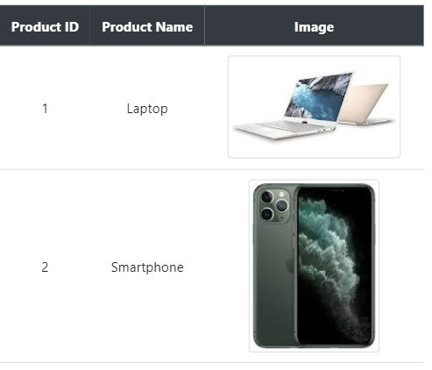

my-component.component.ts  
-----------------------------------------------------------------------------------------------------------------------------------------

import { Component, OnInit } from '@angular/core';

@Component({

  selector: 'app-my-component',

  templateUrl: './my-component.component.html',

  styleUrls: ['./my-component.component.css']

})

export class MyComponentComponent implements OnInit {

  productList:any[] = [

    {

      ID:1,

      Name:"Laptop",

      imgurl:"assets/p1.jpg"

    },

    {

      ID:2,

      Name:"Smartphone",

      imgurl:"assets/p2.jpg"

    },

    {

      ID:3,

      Name:"Speakers",

      imgurl:"assets/p3.jpg"

    },

    {

      ID:4,

      Name:"Smartwatch",

      imgurl:"assets/p4.jpg"

    }

  ]

  constructor() { }

  ngOnInit(): void {

  }

}

-----------------------------------------------------------------------------------------------------------------------------------------

my-component.component.html  
-----------------------------------------------------------------------------------------------------------------------------------------

<div>

        <table class="table table-hover text-center center" style="width: 30%;">

            <thead class="thead-dark align-middle">

                <th scope="col">Product ID</th>

                <th scope="col">Product Name</th>

                <th scope="col">Image</th>

            </thead>

            <tbody>

                <tr *ngFor="let p of productList">

                    <td class="align-middle">{{p.ID}}</td>

                    <td class="align-middle">{{p.Name}}</td>

                    <td class="align-middle"><img [src]='p.imgurl' class="img-thumbnail mx-auto d-block"></td>

                </tr>

            </tbody>

        </table>

    </div>

-----------------------------------------------------------------------------------------------------------------------------------------

**Task 4 : event binding**

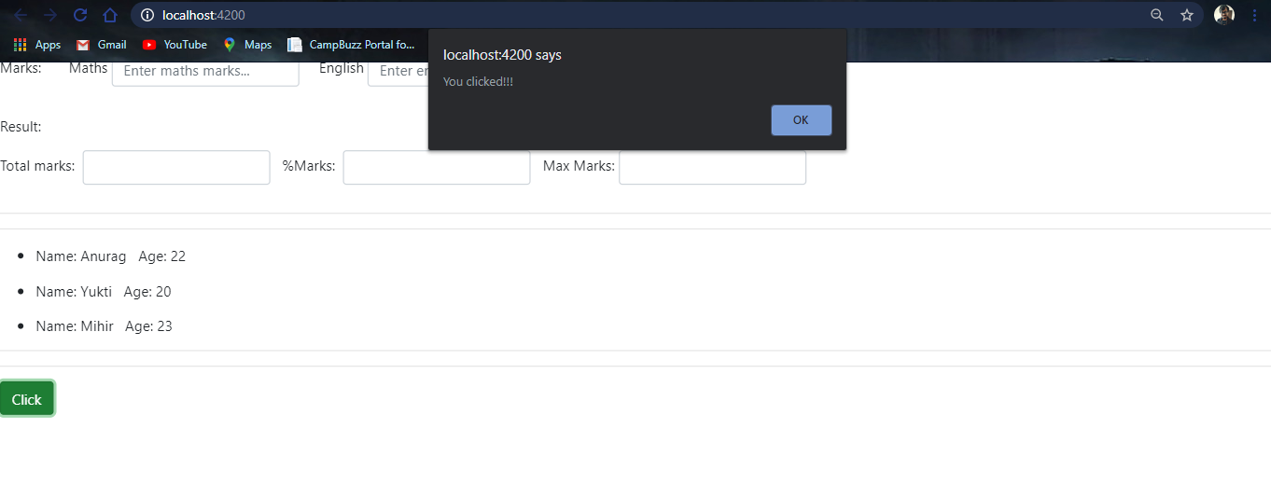

my-component.component.ts  
-----------------------------------------------------------------------------------------------------------------------------------------

import { Component, OnInit } from '@angular/core';

@Component({

  selector: 'app-my-component',

  templateUrl: './my-component.component.html',

  styleUrls: ['./my-component.component.css']

})

export class MyComponentComponent implements OnInit {

  constructor() { }

  ngOnInit(): void {

  }

  clickfunc(){

    alert("You clicked!!!");

  }

}

-----------------------------------------------------------------------------------------------------------------------------------------

my-component.component.html  
-----------------------------------------------------------------------------------------------------------------------------------------

<button (click)="clickfunc()" class="btn btn-success">Click</button>

-----------------------------------------------------------------------------------------------------------------------------------------

**Task 4 : Form Validations**

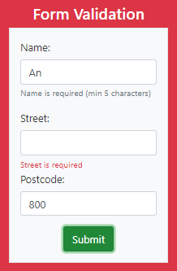

user.ts  
-----------------------------------------------------------------------------------------------------------------------------------------

export interface User {

    name: string;

    address: {

        street: string;

        postcode: string;

    }

}

-----------------------------------------------------------------------------------------------------------------------------------------

my-component.component.ts  
-----------------------------------------------------------------------------------------------------------------------------------------

import { Component, OnInit } from '@angular/core';

import { User } from '../user';

@Component({

  selector: 'app-my-component',

  templateUrl: './my-component.component.html',

  styleUrls: ['./my-component.component.css']

})

export class MyComponentComponent implements OnInit {

  user:User;

  constructor() { }

  ngOnInit(): void {

    this.user = { name:'', address:{street:'',postcode:'8000'}}; //set default to 8000

  }

  save(model:User,isValid:boolean){

    console.log(model,isValid);

  }

}

-----------------------------------------------------------------------------------------------------------------------------------------

my-component.component.html  
-----------------------------------------------------------------------------------------------------------------------------------------

<div class="p-3 mb-2 bg-danger text-white">

    <div class="d-flex justify-content-center" style="padding-top: 10px;">

        <h4>Form Validation</h4>

    </div>

    <div class="d-flex justify-content-center">

        <form #f="ngForm" novalidate (ngSubmit)="save(f.value,f.valid)" class="border  p-3 mb-2 bg-light text-dark" style="padding: 10px;">

            <div class="form-group">

                <label for="name">Name: </label>

                <input type="text" name="name" id="name" class="form-control" [(ngModel)]="user.name" #name="ngModel" required minlength="5">

                <small class="form-text text-muted" [hidden]="name.valid || (name.pristine && !f.submitted)">Name is required (min 5 characters)</small>

            </div>

            <div ngModelGroup="address" class="form-group">

                <div>

                    <label for="street">Street:</label>

                    <input type="text" name="street" id="street" class="form-control" [(ngModel)]="user.address.street" #street="ngModel" required>

                    <small class="form-text text-muted" [hidden]="street.valid || (street.pristine && !f.submitted)" class="text-danger">Street is required</small>

                </div>

                <div class="form-group">

                    <label for="postcode">Postcode:</label>

                    <input type="text" name="postcode" id="postcode" class="form-control" [(ngModel)]="user.address.postcode">

                </div>

            </div>

            <div class="d-flex justify-content-center">

                <button class="center btn btn-success" type="submit">Submit</button>

            </div>

        </form>

    </div>

</div>

-----------------------------------------------------------------------------------------------------------------------------------------